Abstract Template
All-Ukrainian Scientific Conference of Young Scientists
« Geological structure and mineral deposits of Ukraine»
(Kyiv, October 2-3, 2023)

UDС
ABSTRACT TITLE
(FONT 14 pt, UNIT INTERVAL, CAPITAL LETTERS,
(Leveled on the center)
Author¹, Author², Author¹
¹ Company/Institute name, address, e-mail
² Company/Institute name, address, e-mail

Annotation (12 pt). 500-600 signs

Abstract up to three pages (including figures, tables and reference list) should be typed in text editor MS Word. Page format: А4 (21,0 х 29,7 cm), all fields are the same – 2 cm. A font: Times New Roman, the size of a font 14 pt, unit interval, no formatting and hyphenation.
Abstract title, names of the authors, Company/Institute names are levelled on the centre. Abstract title is entered in bold, capital letters; below, author’s surname – in italics; Company/Institute, address (new line for each author), e-mail – general text font. A short abstract (500-600 characters) is placed before the main text. Text paragraphs should have a space of 1 cm and be levelled on width.
Formulas should be placed in the text with the help of Microsoft Equation editor except for simple which do not require special symbols. Physical quantities must be given in standard SI units.
Figures as drawing in lines images should be built into the text and submitted separately as tif, jpg, jpeg image files with a resolution of at least 300 dpi. Cartographic materials are not recommended to be used as figures.
References should be inserted in text as ordinal numbers in square brackets. The list of references is placed at the end of general text in alphabetical order (font size 12 pt); authors’ names – in italics. All accepted abstracts will be published in the author’s version.
The file must be titled (in English) by the surname of the first author with (e.g., Petrenko.doc); file type – MS Word document (*.doc /*.docx). The file with abstract should be sent to e-mail: geologyuks@gmail.com

The main text. The Figure shows …

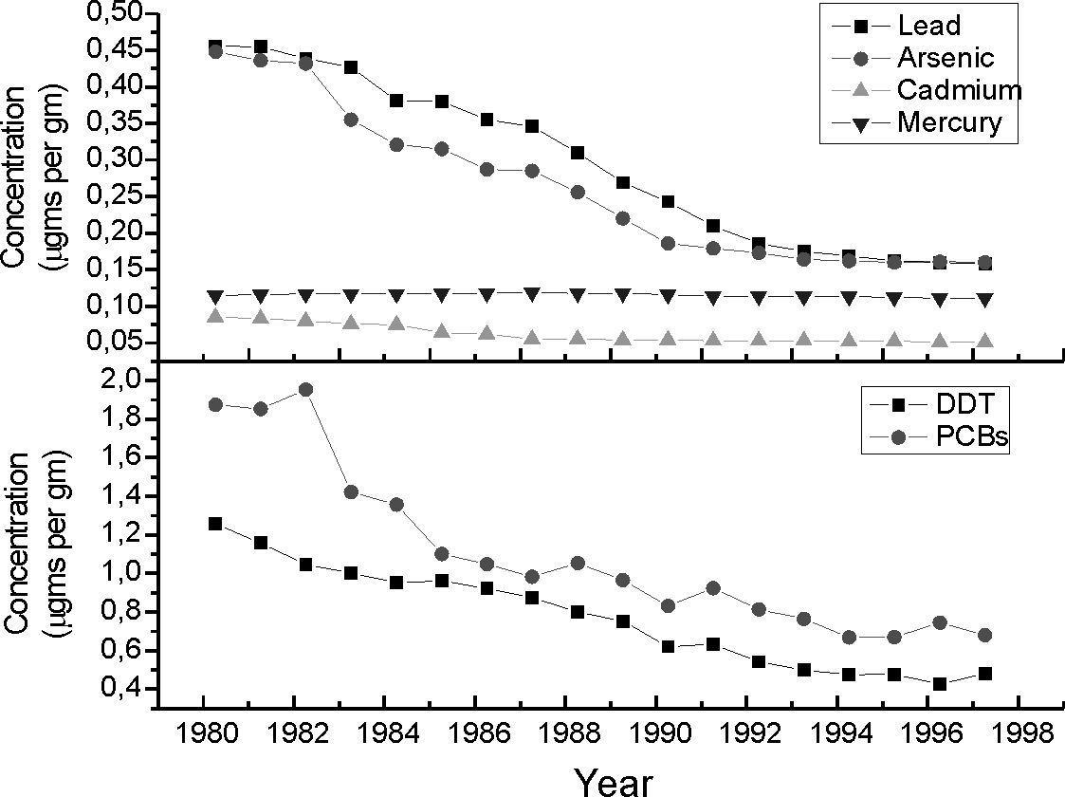
Figure – Title… [2].
The table shows…
Table – Title table
Year | Pb | As | Cd | Hg | ДДТ | ПХД
1980 | 0,456 | 0,448 | 0,085 | 0,115 | 1,256 | 1,874
1981 | 0,455 | 0,436 | 0,083 | 0,116 | 1,157 | 1,852
1982 | 0,439 | 0,432 | 0,08 | 0,117 | 1,045 | 1,952
1983 | 0,427 | 0,355 | 0,076 | 0,117 | 1,002 | 1,421
1984 | 0,381 | 0,321 | 0,075 | 0,117 | 0,952 | 1,357
1985 | 0,38 | 0,315 | 0,064 | 0,118 | 0,961 | 1,1
1986 | 0,355 | 0,287 | 0,062 | 0,118 | 0,921 | 1,047
Note.
References
- Author A.A., Author B.B., Author C.C. Title of article // Title of Journal, 2010. V. 00, № 00. P. 10—20.
- Author A.A. Title of monograph. City: Publisher, 2010. 90 p.
- Author A.A. Title of theses // Conference or other event. City: Publisher, 2010. P. 3—4.

